Chapter 18, Solution 14.

Design a problem to help other students to better understand finding the Fourier transform of a variety of time varying functions (do at least three).

Although there are many ways to solve this problem, this is an example based on the same kind of problem asked in the third edition.

Problem

Find the Fourier transforms of these functions:

- f(t) = e^{-t} cos (3t + π) u(t)
- g(t) = sin π t [ u(t + 1) - u(t-1)]
- h(t) = e^{-2t} cos π t u(t-1)
- p(t) = e^{-2t} sin 4t u(-t)
- q(t) = 4 sgn (t - 2) + 3δ(t) - 2 u(t - 2)

Solution

(a)
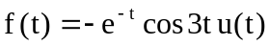
F(ω) = 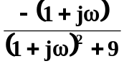

(b)
π
t
g’(t)
-1
1
-π
1
-1
-1
1
t
g(t)

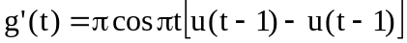
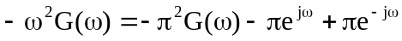
G(ω) = 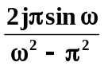

Alternatively, we compare this with Prob. 17.7

f(t) = g(t - 1)
F(ω) = G(ω)e^{-jω}
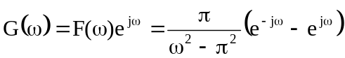
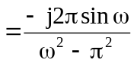
G(ω) = 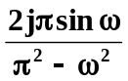

(c)
Let
and 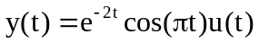
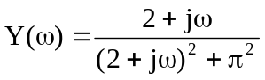
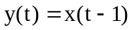
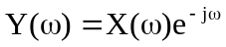
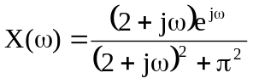
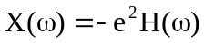
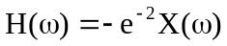
= 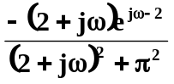

(d) Let 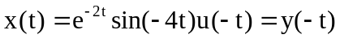
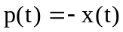
where 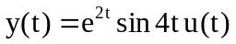
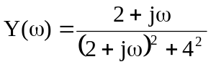
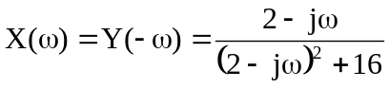
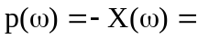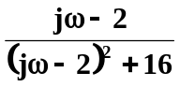

- 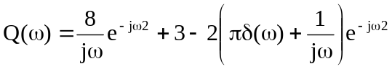
Q(ω) = 